5G/6G Communication Systems- ECA5604 (LAB)
Student Name: U.Guru Prasad Reddy
Reg no: 192312683L
Experiment 8: Steering Angle Variation in MIMO Beamforming Using MATLAB
Aim: To analyze the effect of steering angle variation in a MIMO beamforming system by studying steering angle, array gain, and beam direction error using MATLAB.
Objective 1:
Program:
clc; clear;close all;
angle = [-60 -30 0 30 60]; % Steering Angles (degrees)
gain = ones(size(angle)); % Normalized Gain
figure
polarplot(deg2rad(angle), gain,'o-','LineWidth',2)
title('Steering Angle Variation in MIMO Beamforming')
Output:
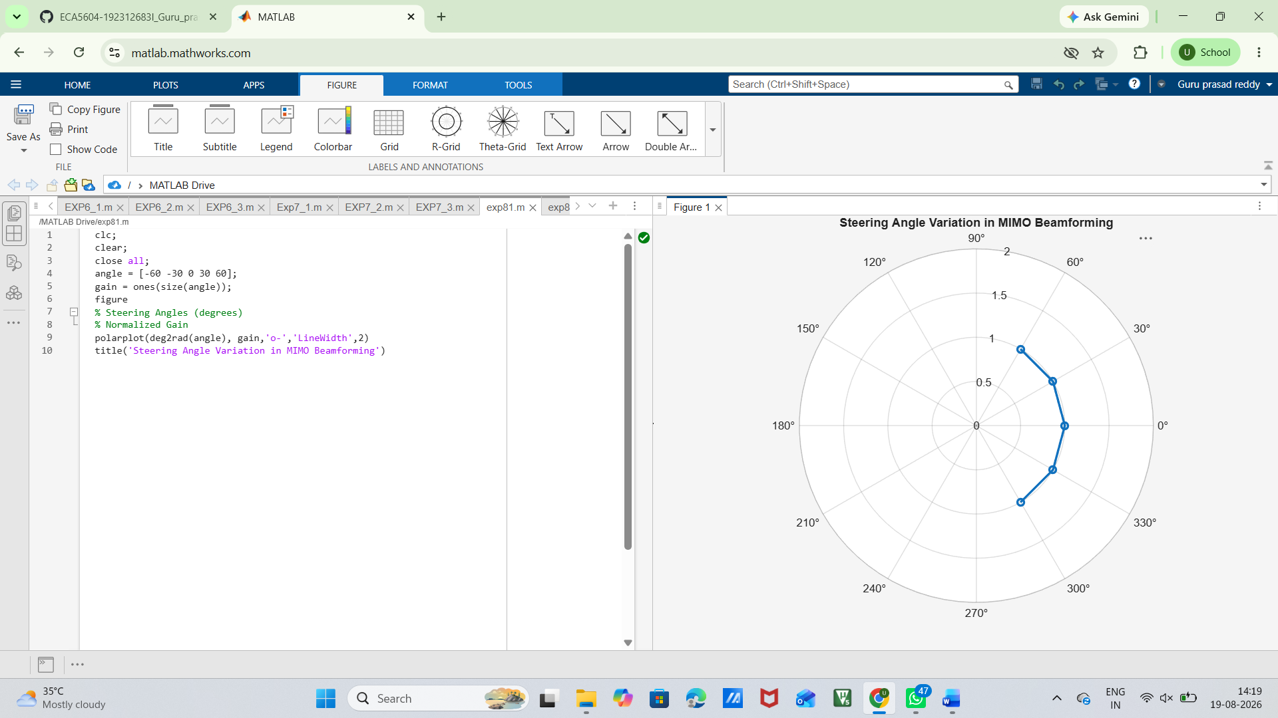

Objective 2:
Program:
clc;
clear;
close all;
angle = [-60 -30 0 30 60]; % Steering Angles (degrees)
gain = [9 12 15 12 9]; % Array Gain (dB)
figure
bar(angle, gain)
grid on
xlabel('Steering Angle (Degrees)')
ylabel('Array Gain (dB)')
title('Array Gain for Different Steering Angles')
Output:
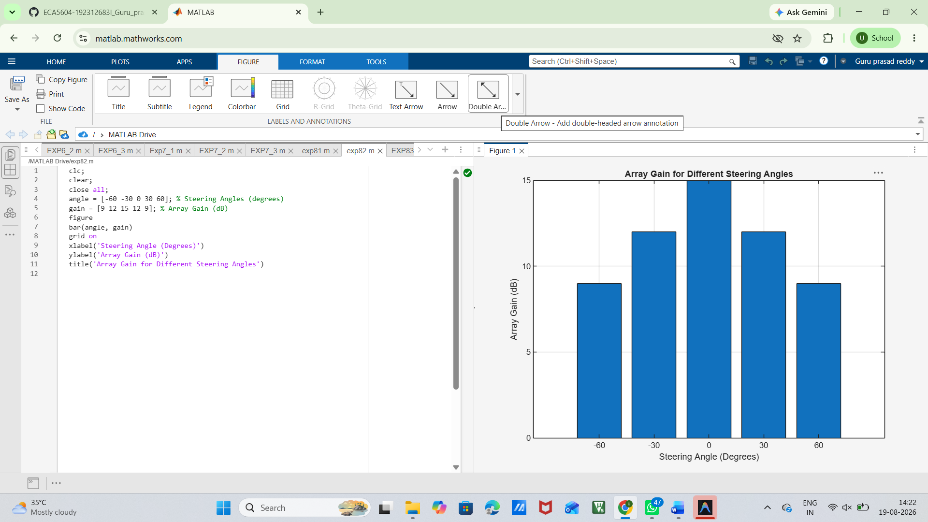
Objective 3:
MATLAB Code:
clc;
clear;
close all;
desired = [-60 -30 0 30 60]; % Desired Steering Angle (degrees)
actual = [-58 -32 1 29 62]; % Actual Beam Direction (degrees)
error = abs(desired - actual); % Beam Direction Error
figure
plot(desired, error, 'o-', 'LineWidth', 2)
grid on
xlabel('Desired Steering Angle (Degrees)')
ylabel('Beam Direction Error (Degrees)')
title('Beam Direction Error for Different Steering Angles')

Output:
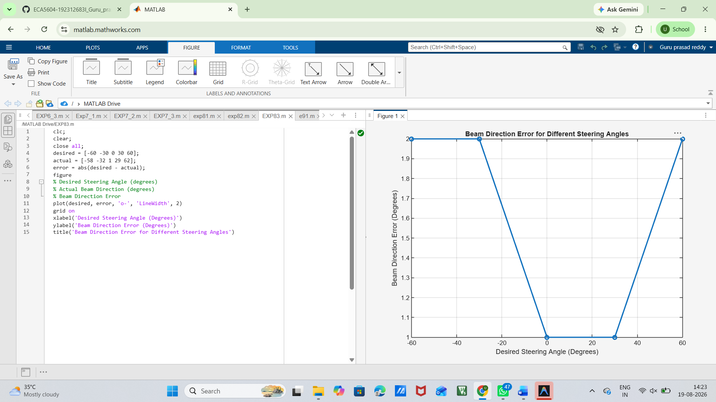
Result:
The MIMO beamforming system was successfully analysed, showing that steering angle controls beam direction, array gain varies with steering angle, and beam direction error can be evaluated accurately using MATLAB.

